
FT/CHAK/1119A 16/06/2019
FIRST TERM EXAMINATION (2019-2020)
SUBJECT: CHEMISTRY  GRADE: XI |  | MAX. MARKS: 70  TIME: 3 HRS
No of printed pages 7
Marking Scheme
1. | No two electrons in an atom can have the same set of four quantum numbers.  OR  Only two electrons may exist in the same orbital and these electrons must have opposite spin. |  |  |  |  |  | (1)
2. | Azimuthal quantum number or angular momentum quantum number |  |  |  |  |  | (1)
3. | 3d_{xy}= 3d_{z2}=3d_{yz},  4d_{yz}=4d_{xy},  OR  5s and lowest n+l |  |  |  |  |  | ½ each
4. | 6 |  |  |  |  |  | (1)
5. | 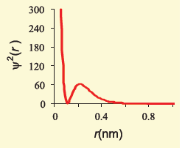 |  |  |  |  |  | (1)
6. | K=[Ar]4s¹ |  |  |  |  |  | (1)
7. | 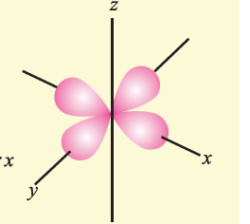 |  |  |  |  |  | (1)
8. | 4th period and 16th group |  |  |  |  |  | ½ each
9. | 40% |  |  |  |  |  | (1)
10. | 6 |  |  |  |  |  | (1)
11. | P < Si <Be < Mg < Na.  OR  The largest species is Mg; the smallest one is Al³⁺. |  |  |  |  |  | (1)
12. | C₃H₆O₃ |  |  |  |  |  | (1)
13. | F> N> C >B |  |  |  |  |  | (1)
14. | Orbitals available  7s,5f,6d,7p  2+14+10+6=32 elements |  |  |  |  |  | (1)
15. | 1.66 M |  |  |  |  |  | (1)
16 | Mole fraction/Mass percentage/Molality |  |  |  |  |  | (1)
17. | Unniloctium Uno |  |  |  |  | ½ each
18 | Al₂S₃ |  |  |  |  |  | (1)
19 | angular nodes-2 and radial nodes -1  OR  16 |  |  |  | (1/2 each)  1
20 | 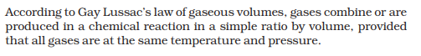 |  |  |  |  |  | (1)
21 | Any two differences between orbit and orbital. |  |  |  |  |  | (1x2)
22. | 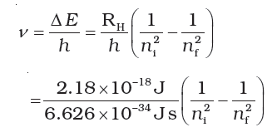  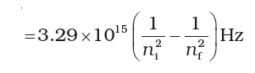  Substitution  4.57x10¹⁴s⁻¹ |  |  |  |  |  | ½  ½  1
23. | 3Fe + 4H₂O→ Fe₃O₄ +4H₂  72g of steam reacts with 168g of Fe  12g of steam will react with=28g  OR  2 mol of KClO₃ gives 22.4 x 3 L of O₂  0.05mol of KClO₃ gives 1.68L of O₂ |  |  |  |  |  | (1x2)
24. | 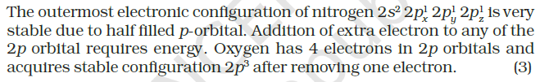 |  |  |  |  |  | (1+1)
25. | Simplest whole no ratio C₄H₃O₂  Empirical formula mass=83  n=2  Formula C₈H₆O₄ |  |  |  |  |  | ½ x4
26. | period-4 and group-9  Any two general properties of d block |  |  |  |  |  | ½ x4
27. | 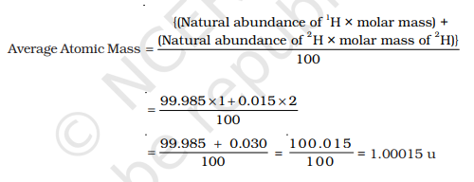 |  |  |  |  |  | ½ x4
28. | Give reasons:  - Stable electronic configuration, energy needed to add an electron as it goes to next valence shell.  - Electronic configuration of Mg is more stable than B. 3p electron in Al more shielded than 3s in Mg thus easily removed.  - When electron is added to F, the added electron goes to the smaller n = 2 quantum level and suffers significant repulsion from the other electrons present in this level. For the n = 3 quantum level (Cl), the added electron occupies a larger region of space and the electron-electron repulsion is much less. |  |  |  |  |  | (1x3)
29 | 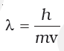  m_{e}=9.1x10⁻³¹  =6.626x10⁻³⁴/9.1x10⁻³¹x1.6x10⁶  =4.55x10⁻¹⁰ m (deduct ½ if unit not mentioned)  OR  m_{e}=1.67x10⁻²⁷  =6.626x10⁻³⁴/1.67x10⁻²⁷x800x10⁻¹²  =4.94x10² m/s (deduct ½ if unit not mentioned) |  |  |  |  |  | ½  ½  1  1  ½  ½  1  1
30 | N₂ (g) + 3H₂ (g)→ 2NH₃ (g)  - N₂ is the limiting reagent  Mass of NH₃=2428.6g  (ii) H₂ remains unreacted  H₂ unreacted=571.42g |  |  |  |  |  | ½  1  ½  1
31 | Account for the following:  a) Mg²⁺ is smaller than O²⁻, although both are isoelectronic as effective nuclear charge per electron is more.  b) Oxygen has four electrons in 2p orbital, two electrons in same 20 orbital suffer repulsion so easily removed while nitrogen has half-filled stable configuration so more energy required to remove it.  c) Halogens have large negative electron gain enthalpy sine they need one electron to achieve noble gas configuration. |  |  |  |  |  | (1x3)
32 | Calculate the mass of the following:  a)5.314x10⁻²³ g  b) 2.657g  c) 0.01g |  |  |  |  |  | (1x3)
33 | a) It states that it is impossible to determine simultaneously, the exact position and exact momentum (velocity) of an electron.  b) 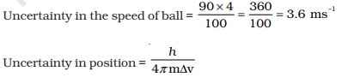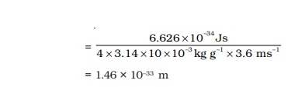 |  |  |  |  |  | (1)  ½  ½  ½  ½
34 | a) In cation nuclear charge remains same while the number of electrons decreases thus effective nuclear charge per electron increases, size decreases.  In anions, number of electrons increases after addition of electron, so effective nuclear charge per electron, decreases so they are larger in radii than their parent atoms  b) Isotopes have same atomic number, same no of electrons and the nuclear charge. They’ll have same ionization enthalpy. |  |  |  |  |  | (2+1)
36 | - When an electron is added to a neutral gaseous atom (X) to convert it into a negative ion, the enthalpy change accompanying the process is defined as the Electron Gain Enthalpy (Δ_{eg}H).  - (n-1)d¹⁻¹⁰ns¹⁻²  - Name the following and give the reason:  - an inert element D- Highest first IE and positive electron gain enthalpy  - most reactive metal A- Lowest first IE  - most reactive nonmetal B High IE and negative electron gain enthalpy  (OR)  a) It represents the energy required to remove an electron from an isolated gaseous atom (X) in its ground state.  b) Cl₂O₇ is an acidic oxide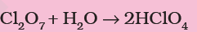  c) (n-2)f¹⁻¹⁴ (n-1)d^{0–1}ns²  d) First electron is added easily and the energy is given out while Second electron gain enthalpy is positive indicating it requires energy to add the second electron to an anion due to repulsion, energy needs to be provided for it.  e) Li and Mg or B and Al |  |  |  |  |  | (1x5)
36 | - Molality is the number of moles of solute present in one kilogram of solvent  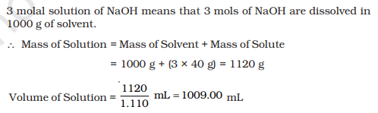  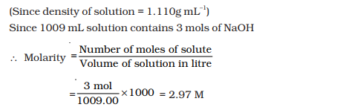  - 1Molar solution. 1mole of solute in 1000ml of solution while for molality it is one of solute in 1000g of solvent.  OR  - Ratio of no of moles of one component to the total number of moles of all the components of the solution.  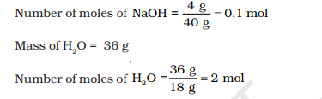  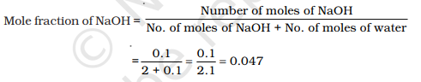  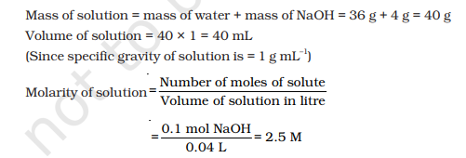  - Molality. Molality is independent of temperature whereas molarity depends on temperature. |  |  |  |  |  | 1  1  1  1  ½ each  1  ½  ½  1  ½  ½  ½ each
37 | - Car has large mass so wavelength associated with it is negligible.  - 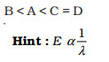  - λ =c/ῠ  λ=0.649x 10⁻⁶ m=649.4nm  Visible region  - Splitting of spectral lines in the magnetic field  OR  - 9  - The unpaired electrons in 3p orbital of Si will experience more effective nuclear charge from the nucleus due to more protons  - Dual behaviour of matter and Heisenberg uncertainty principle  - quantum numbers are not possible  ii. n = 3, l = 3, ml = 1 , ms = +1/2 n cannot be equal to l  iv. n = 3, l = 4, ml = 1 , ms = +1/2 l cannot be more than n |  |  |  |  |  | 1  1  ½  1  ½  1  (1x5)
***

